
The University Of Azad Jammu &
Kashmir,Muzaffarabad

Name: Hassan Gillani
Roll NO: 2024-SE-42
Course Code:CS-2203
Submission Date:19thMay,2026
Course Title: Computer Networks
Instructor Name: Engr. Asma Javaid

Department Of Software Engineering
LAB TASK 1- INTERCONNECTING TWO SWITCHES WITH 6 PCS

Objective
- To interconnect two switches in a LAN
- To connect six PCs across two switches
- To verify communication using ICMP (Ping) in Simulation Mode

Apparatus / Requirements

- 2 2960 Switches
- 6 PCs
- Copper Straight-Through wires
- Cisco Packet Tracer
A switch is a networking device used to connect multiple devices in a Local Area Network (LAN). When two switches are connected, they allow communication between devices connected to different switches.
Switches forward data using MAC addresses. In this lab, ICMP protocol (ping) is used to test connectivity.
Also, Spanning Tree Protocol (STP) runs in the background to prevent loops.
Procedure:

Create Topology
• Open Cisco Packet Tracer • Place:
o 2 switches o 6 PCS

Connect Devices
PC Connections:
- PC0 → Switch0 (Fa0/1)
- PC1 → Switch0 (Fa0/2)
- PC2 → Switch0 (Fa0/3)
- PC3 → Switch1 (Fa0/1)
- PC4 → Switch1 (Fa0/2)
- PC5 → Switch1 (Fa0/3)
Switch-to-Switch Connection:
- Switch0 (Fa0/24) → Switch1 (Fa0/24)

Assign IP Addresses

PC | IP Address | Subnet Mask
PC0 | 192.168.1.1 | 255.255.255.0
PC1 | 192.168.1.2 | 255.255.255.0
PC2 | 192.168.1.3 | 255.255.255.0
PC3 | 192.168.1.4 | 255.255.255.0
PC4 | 192.168.1.5 | 255.255.255.0
PC5 | 192.168.1.6 | 255.255.255.0

Simulation Testing
• Switch to Simulation Mode • Use Add Simple PDU (envelope icon) • Send packet from:
o PC5 → PC1
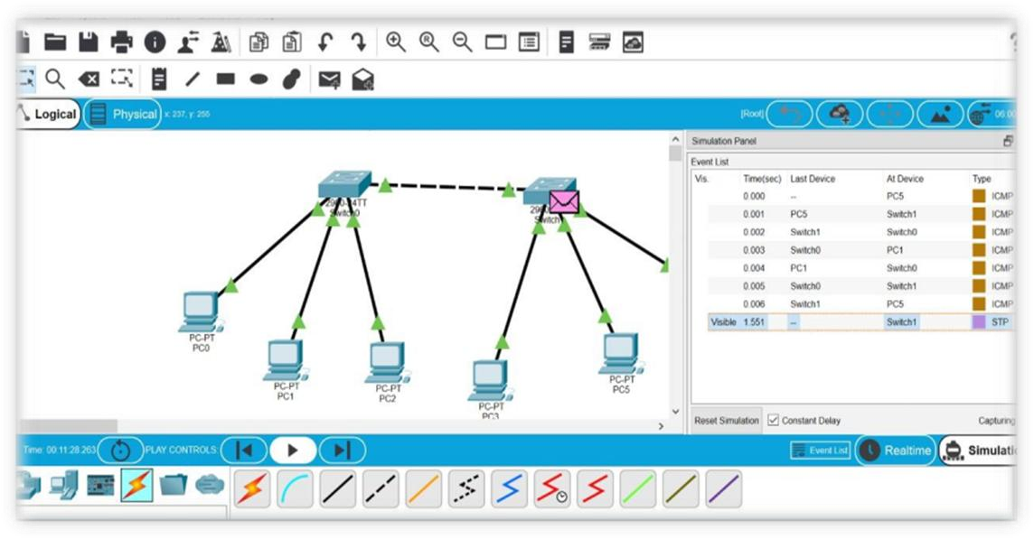

Observe Packet Flow
From Simulation Event List:
PC5 → Switch1 → Switch0 → PC1 → Switch0 → Switch1 → PC5
✔ This shows:
- Request reached destination
- Reply returned successfully

Observations

- Successful ICMP packets confirm connectivity
- Data travels through both switches
- STP protocol is visible in simulation (normal behavior) • Green indicators show active links

Precautions

- Ensure all PCs are in same network
- Use correct cable type
- Wait for links to turn green
- Avoid duplicate IP addresses

Result
The two switches were successfully interconnected, and communication between six PCs was verified using simulation mode and ICMP protocol.

Conclusion;
The experiment demonstrated that multiple PCs connected to different switches can communicate successfully when switches are interconnected, and data transmission was verified using ICMP in simulation mode.

